EXPERIMENT 5

DDL COMMANDS (COLLEGE SCHEMA)

Aim:

* Create a schema called College.
* Create tables for students (attributes: student id, name, gender, subject, marks and grade), faculty (attributes: faculty id, name, course and pass percentage),

department (attributes: department id, name, section, strength and pass percentage) and activity (attributes: activity id, name, strength and category)

* Add and modify:
  + Address in students table, change datatype size of student name and make student id primary key
  + Add faculty total mentor details, make faculty id as primary key
  + Add number of students in wise in department table and make department id as primary key
  + Add faculty name to activity table, change the datatype size of activity name and make activity id as primary key

MySQL:

create table student(studid integer, studname varchar(10), gender varchar(1), subject varchar(10), marks integer, grade varchar(1));

create table faculty(fac_id integer, fac_name varchar(10), course varchar(5), pass_perc integer);

create table department(dept_no integer, dept_name varchar(4), section integer, no_of_students integer, pass_perc integer);

create table activity(act_id integer, act_name varchar(20), no_students_opted integer, category_of_activity varchar(10));

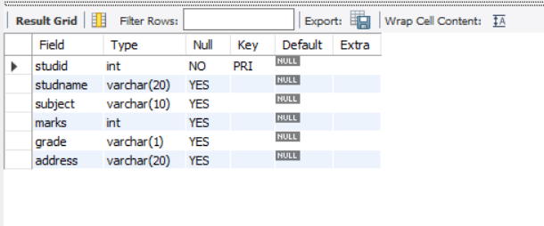

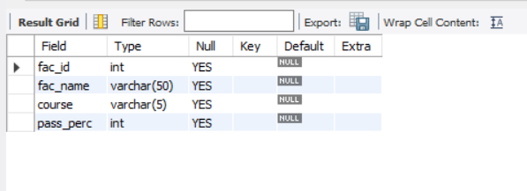

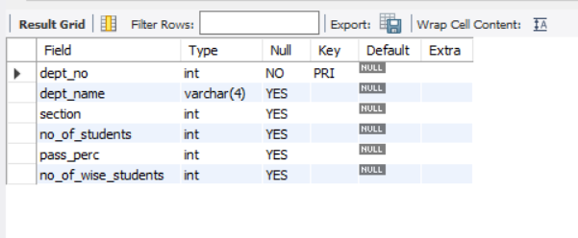

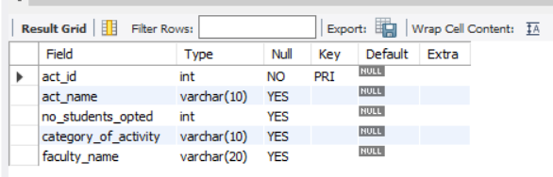

ALTER table student add(address varchar(20));

ALTER table student add(primary key(studid));

ALTER table student modify studname varchar(20);

ALTER table student drop gender;

ALTER table faculty add(total_mentor_details varchar(30), primary key(fac_id));

ALTER table department add(no_of_wise_students int, primary key(dept_no));

ALTER table activity add(faculty_name varchar(20), primary key(act_id));

ALTER table activity modify act_name varchar(10);